ANIMAL KINGDOM

Characteristics:
- Heterotrophs
- Eukaryotic
- Multicellular with tissues (some of them are colonies)
- Sexual reproduction (some have asexual too)
- Have highly developed sensitivity
- Can move about
- Live in all type of environments

Classification:
- Invertebrates:
  - Poriphera (sponges)
  - Cnidaria (Polyps and jellyfish)
  - Annelids and other worms
  - Molluscs
  - Echinoderms
  - Arthropods

- Vertebrates:
  - Fish
  - Amphibians
  - Reptiles
  - Birds
  - Mammals

- Invertebrates:
The simplest forms of animals are aquatic and most of them live in marine environments.
PORIFERA:
Sponges live attached to surfaces on the ocean floor. The body is covered with small pores (poros) connected with each other through thin channels. Most sponges filter water, they are called filter feeders. They have also a supportive skeleton consisting of small spicules (espículas) made of a soft but resistant material.
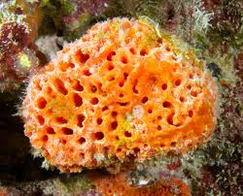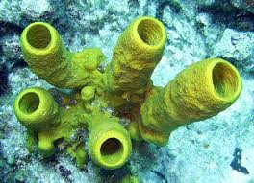
CNIDARIA :
Polyps and jellyfish are classified in Cnidaria. They are carnivorous and catch the prey with their poisonous tentacles. Both are radially symmetrical, but differ in many things:
- Polyps have a sac-like body with a hole surrounded by tentacles that is the mouth and the anus. They live attached to a rock.
- Jellyfish have an umbrella-shaped body and float free in water.
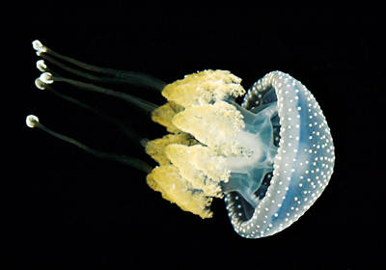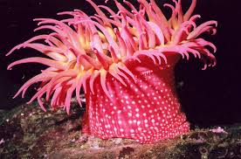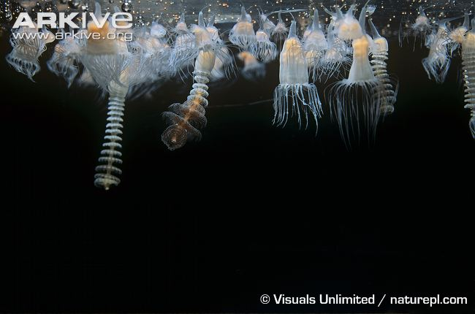

Life cycle of polyps and jellyfish:

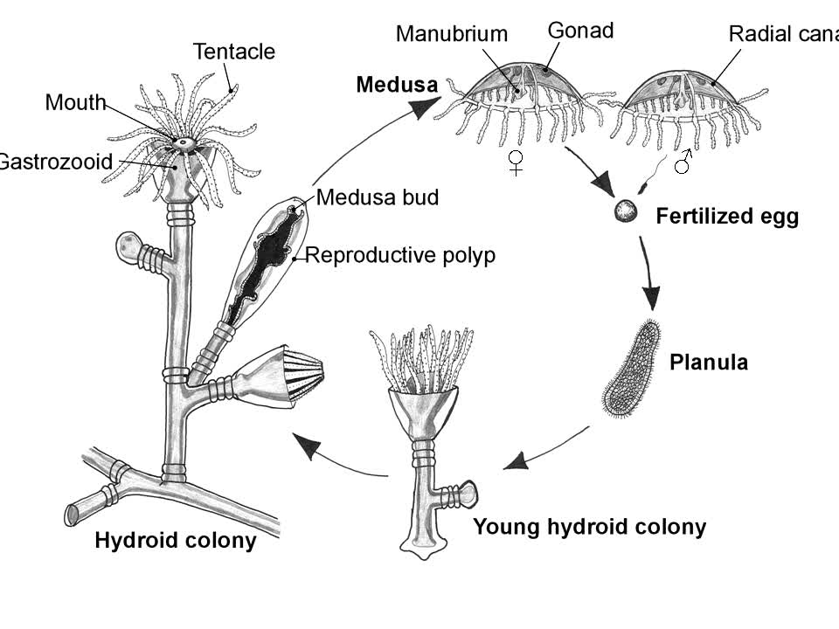

ANNELIDS (SEGMENTED WORMS)

Earthworms, leeches and many marine worms are annelids. Most of them are aquatic, but the earthworm lives in moist soil.
The body is divided in segments that have tiny bristles called setae, which help the worm move. There is a segment that contains the reproductive organs, it is called clitellum.
The symmetry is bilateral. They breathe through the skin and need to be permanently moist (cutaneous respiration).
Earthworms are hermaphrodites.
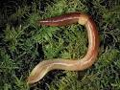

OTHER WORMS:
PLATHYHELMINTHES or flat worms: Most of them are parasites (tapeworm or solitaria or tenia) and other aren’t (planarians o planarias). The tapeworm are between 2 and 8 meters long with a head, called scolex and hundreds of flattened rings. They have a set of hooks and suckers to attach themselves to the walls of the intestines.
Planarians are very small and fragile but able to regenerate lost body parts.
NEMATODES: worms with a cylindrical body that is thinner at the ends than in the middle. They live in water or damp ground, but some are parasites like the intestinal worms.
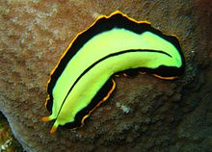
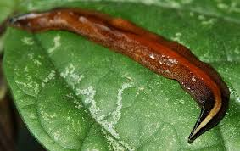
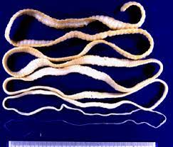

MOLLUSCS
Snail, mussels and squid are molluscs. Their body is soft but is not divided into segments.
They have a strong muscular foot to support the body and to move.
They have a layer of tissue called mantle that contains the organs. Many mollusks have a protective calcareous shell. It can be made of one piece or two pieces (valves).
Groups:
- Gastropods (pie en el estómago=q se mueven sobre su estómago): snail
- Bivalves (bivalvos): like mussels
- Cephalopods (pie en la cabeza…): octopi and squids
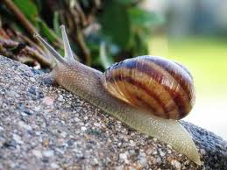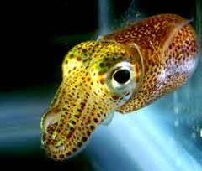

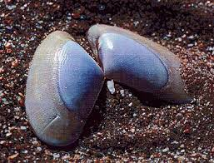

ECHINODERMS
Sea urchins and starfish are echinoderms. Many echinoderms have a hard endoskeleton made of calcareous plates and are covered with spines.
Starfish have a flat body, which consists of a central disc with 5 arms. The mouth is located on the underside. They have radial symmetry and are carnivores.
Echinoderms move about using a unique system called the water vascular system. A series of internal channels are connected to lots of tiny tube feet, which end in suction cups.
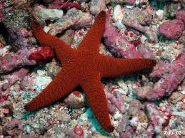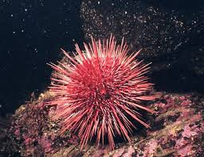

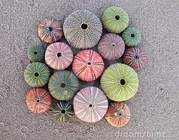

ARTHOPODS (PATAS ARTICULADAS)
Spiders, centipeds, crabs, ants and butterflies are arthropods. Characteristics:
- A segmented body: head, thorax and abdomen. Bilateral symmetry.
- Articulated limbs.
- A hard exoskeleton that have to be replaced periodically (moulting) (muda)
- Simple or compound eyes
- They breathe through gills or tracheae
- They are oviparous and some undergo incomplete or complete metamorphosis.
Groups:
- Aracnids: 8 legs, cephalothorax, abdomen and antennae. Simple eyes. They have a pair of pedipalps (senses or pincers) and 4 pairs of legs. They are chelicerate arthropods. Spiders and scorpions. They live in hot and dry environments and are carnivores.
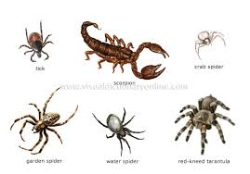
- Crustaceans: Mandibulate arthropods. Body divided into cephalothorax and abdomen. Antennae and 10 or more legs. A pair of compound eyes. Aquatic, many of them are edibles (comestibles), They have a hard calcareous exoskeleton. Shrimp, lobster, crabs and prawns. Mostly of them are carnivores.
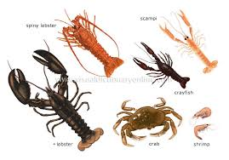
- Myriapods (many -footed): terrestrial mandibulate that can be either carnivores or herbivores. Body divided into head and trunk made of many rings. Each ring has a pair of antennae and 2 pairs of legs. Two groups of somple eyes. The goup includes centipeds (poisonous) and milipeds.
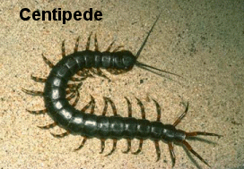

- Insects: the largest and most diverse group. Mandibulate and terrestrial. They can be carnivores, herbivores, scavengers or parasites. Head, thorax and abdomen, 1 pair of antennae, three pairs of legs and most have wings (2 pairs), a pair of compound eyes.
